**JOINS**

**EXPT NO: 4 DATE: 3/10/22**

**AIM**

To study SQL Joins

**THEORY**

A JOIN clause is used to combine rows from two or more tables, based on a related column between them. It is basically Cross Product / Cartesian Product plus Select statement

Different Types of SQL Joins

The different types of joins are as follows:

* INNER JOIN
* NATURAL JOIN
* LEFT OUTER JOIN
* RIGHT OUTER JOIN
* FULL OUTER JOIN

**(I) INNER JOIN**

It is one of the simplest joins. The INNER JOINkeyword selects all the rows from both tables as long as the condition is satisfied. This keyword will create the result-set by combining all rows from both the tables where the condition satisfies i.e., the value of the common field will be same. In simple words it returns records that having matching values in both tables

Syntax:

SELECT * FROM table1 INNER JOIN table2 ON table1.Column_Name = table2.Column_Name;

Note: We can also write JOIN instead of INNER JOIN. JOIN is same as INNER JOIN

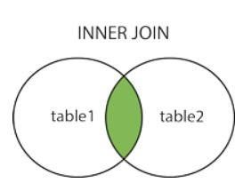

**(II) NATURAL JOIN**

Natural Join joins two tables based on same attribute name and data-types, The resulting table will contain all the attributes on both the table but keep only one copy of each common column. In Natural Join, if there is no condition specified then it returns the rows based on the common column.

Syntax**:**

SELECT * FROM table1 NATURAL JOIN table2;

**(III) LEFT OUTER JOIN**

This join returns all the rows of the table on the left side of the join and matches rows for the table on the right side of the join. For the rows for which there is no matching row on the right side, the result-set will contain *null*. LEFT OUTER JOIN is also known as LEFT JOIN. In simple words, it returns all records from left table and the matched records from right table.

Syntax:

SELECT table1.column… FROM table1 LEFT OUTER JOIN table2 ON table1.matching_column = table2.matching_column

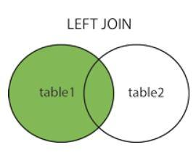

**(IV) RIGHT OUTER JOIN**

This join returns all the rows of the table on the right side of the join and matching rows for the table on the left side of the join. For the rows for which there is no matching row on the left side, the result-set will contain null. RIGHT OUTER JOIN is also known as RIGHT JOIN. In simple words, it returns all records from right table and the matched records from left table.

Syntax:

SELECT table1.column… FROM table1 RIGHT OUTER JOIN table2 ON table1.matching_column = table2.matching_column

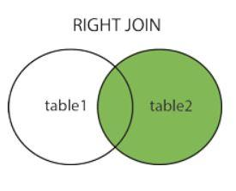

**(V) FULL OUTER JOIN**

FULL OUTER JOIN creates the result-set by combining results of both LEFT OUTER JOIN and RIGHT OUTER JOIN. The result-set will contain all the rows from both tables. For the rows for which there is no matching, the result-set will contain *NULL* values.

Syntax:

SELECT table1.column… FROM table1 FULL OUTER JOIN table2 ON table1.matching_column = table2.matching_column

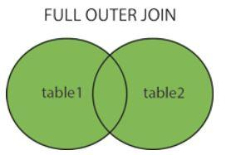

**CONCLUSION**

The various MySQL join operation commands were studied along with its appropriate use cases.